**Notification Service**

**Goal**

We will build a Notification Service from scratch which can send SMS to users. Idea is to get hands-on experience in Java, Springboot, Mysql, Kafka, Redis, Elastic Search.

**Design**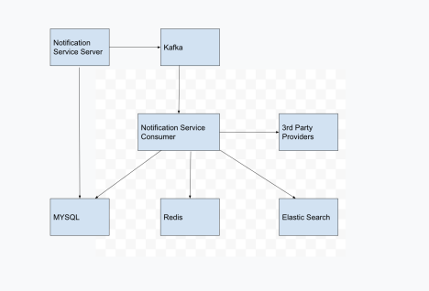

**Notification Service API**

**Authentication Header**

| ANY REQUEST | |
| --- | --- |
| Headers | Key : meesho@123 |

#### 

#### **Send SMS API**

| POST /v1/sms/send | |
| --- | --- |
| Body | {  "phoneNumber" : "+919285007135",  "message" : "hello this is a test message"  } |
| Success Response: | {  "data": {  "requestId": "some_unique_id",  "comments": "Successfully Sent"  }  } |
| Sample Failure Response:  Http status : 400 | {  "error": {  "code": "INVALID_REQUEST",  "message": "phone_number is mandatory"  }  } |

#### **Add a phone_number to blacklist -> Update cache and DB**

| POST /v1/blacklist | |
| --- | --- |
| Body | {  "phoneNumbers": [  "+91904353454534",  "+91980998787678"  ]  } |
| Success Response: | {  "data": "Successfully blacklisted"  } |

#### **Remove a number from blacklist**

| DELETE /v1/blacklist | |
| --- | --- |
| Body | {  "phoneNumbers": [  "+91904353454534",  "+91980998787678"  ]  } |
| Success Response: | {  "data": "Successfully whitelisted"  } |

#### **Get list of blacklisted numbers**

| GET /v1/blacklist | |
| --- | --- |
| Success Response: | {  "data": [  "+91904353454534",  "+91980998787678"  ]  } |

#### 

#### **Get details of sms from request_id (Get from Mysql DB)**

| GET /v1/sms/<request_id> | |
| --- | --- |
| Success Response: | {  "data": {  "id":  "phoneNumber":  "message":  ……. All other details from the table …...  }  } |
| Sample Failure Response:  Http status : 404 | {  "error": {  "code": "INVALID_REQUEST",  "message": "request_id not found"  }  } |

#### 

#### **Get all sms sent to phone number between given start and end time from elastic search**

| POST /v1/messages/find-in-time | |
| --- | --- |
| Body | {  "phoneNumber": "+919285007135",  "startTime": "2024-01-29T16:02:28",  "endTime": "2024-01-29T16:02:55",  "pageDetails":{  "page":0,  "size":10  }  } |
| Success Response: | {  "data": [  {  "id": 3,  "phoneNumber": "+919285007135",  "message": "Hello World",  "createdAt": 1706524348000,  "updatedAt": 1706524348000  }  ],  "pageDetails": {  "page": 0,  "size": 10  }  } |

#### 

#### 

#### **Get all sms containing given text from elastic search**

| POST /v1/messages/find-by-text | |
| --- | --- |
| Body | {  "text": "message",  "pageDetails":{  "page":0,  "size":10  }  } |
| Success Response: | {  "data": [  {  "id": 3,  "phoneNumber": "+919285007135",  "message": "Hello World",  "createdAt": 1706524348000,  "updatedAt": 1706524348000  }  ],  "pageDetails": {  "page": 0,  "size": 10  }  } |

#### 

### **3rd Party API**

| POST https://api.imiconnect.in/resources/v1/messaging | |
| --- | --- |
| Headers | Key: “oooooooooo” |
| Body | [  {  "deliverychannel": "sms",  "channels": {  "sms": {  "text": "Hello, Greetings from Meesho.Click here to know more about us:https://meesho.com."  }  },  "destination": [  {  "msisdn": [  "+919940630272"  ],  "correlationId": "some_unique_id"  }  ]  }  ] |

### **Common Errors Response**

| Invalid Phone Numbers Response:  Http status : 400 | {  "error": {  "code": "INVALID_REQUEST",  "message": "check your phoneNumber"  }  } |
| --- | --- |
| Bad page variables Response:  Http status : 4xx | {  "error": "Page index Should Be Non-Negative & Size should have range(1-50)"  } |
| Can’t Read Request Response:  Http status : 4xx | {  "error": {  "code": "Failed to read request. Please check the request format and try again.",  "message": "JSON parse error: Cannot deserialize value of type `java.time.LocalDateTime` from String \"2024-01-29T16:0:28\": Failed to deserialize java.time.LocalDateTime: (java.time.format.DateTimeParseException) Text '2024-01-29T16:0:28' could not be parsed at index 14"  }  } |
| Mandatory fields of request are empty Response:  Http status : 4xx | {  "error": {  "code": "EMPTY_FIELDS",  "message": "All fields are mandatory"  }  } |